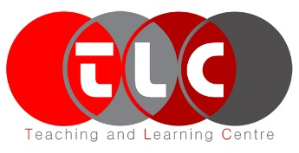
TOTAL Teacher Experience
‘Transforming Outcomes Through Action Learning’
2018-19

Summary Report
(only Point Form needed)
Name of participating faculty | :
Participating course | :
Term | :
ILO(s) focused | :
 | :
Reporting date | :

Phase 1

The most relevant points in the student feedback (i.e. from the TOTAL Questions) received:

Description of your Action Plan:
(based on the student feedback from the TOTAL questions, student performance from the mini-assignment addressing the ILO(s) focused and your own observations from Reflective Journal)

Phase 2

The most relevant points in the student feedback (i.e. from the TOTAL Questions) received:

Description of your Action Plan in the Next Delivery:
(based on student feedback from the TOTAL questions, student assessment performance and your own observations from Reflective Journal)

Note:
The templated can be customized for your own use, as long as it can fit the reporting purpose.

